4.6 Repeat change (no standard)
It is possible to change the drive ratio between the main shaft and the pattern drum by exchan­ ging the toothed belt disks on the repeat preset gear as follows:

repeat | "'toothed belt disk |  | *length of toothed belt | *arrangement  of tension rollers
repeat | A | B | *length of toothed belt | *arrangement  of tension rollers
1: 24 | 24 | 36 | 720mm | 1
1 : 20 | 36 | 45 | 800mm | 1 | no standard
1 : 18 | 32 | 36 | 720mm | 2 | no standard
1 : 16 | 40 | 40 | 800mm | 1
1 : 14 | 32 | 28 | 720mm | 2 | no standard
1 : 12 | 40 | 30 | 720mm | 2
. 1 : 10 | 48 | 30 | 800mm | 1
*For order numbers, pis. see spare parts catalogue.

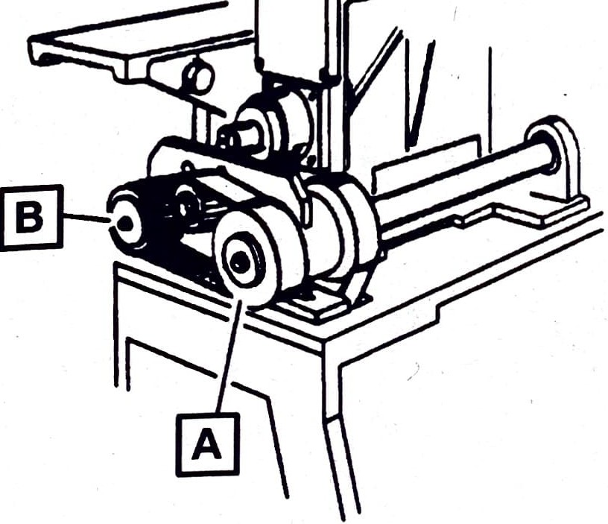
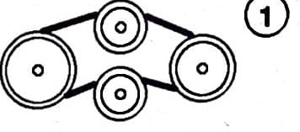
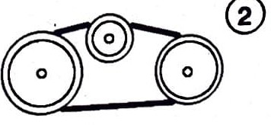
L--

