4.9 Repeat change (no standard)
It is possible to change the drive ratio between the main shaft and the pattern drum by exchan­ ging the toothed belt disks on the repeat preset gear as follows:

Rapport | 1rtoothed belt disk |  | *length of toothed belt | *arrangement  of tension rollers
Rapport | A | B | *length of toothed belt
24: 1 | 24 | 36 | 560mm | B | 0  0 | 0 | A
.. 20: 1 | 36 | 45 | 640mm
.. 18: .1 | 32 | 36 | 600mm
16: 1 | 30 | 30 | 560mm
.. 14: 1 | 32 | 28 | 560mm
12: 1 | 40 | 30 | 600mm
10: 1 | 48 | 30 | 640mm
*For order numbers, pis. see spare parts catalogue.
.. no standard

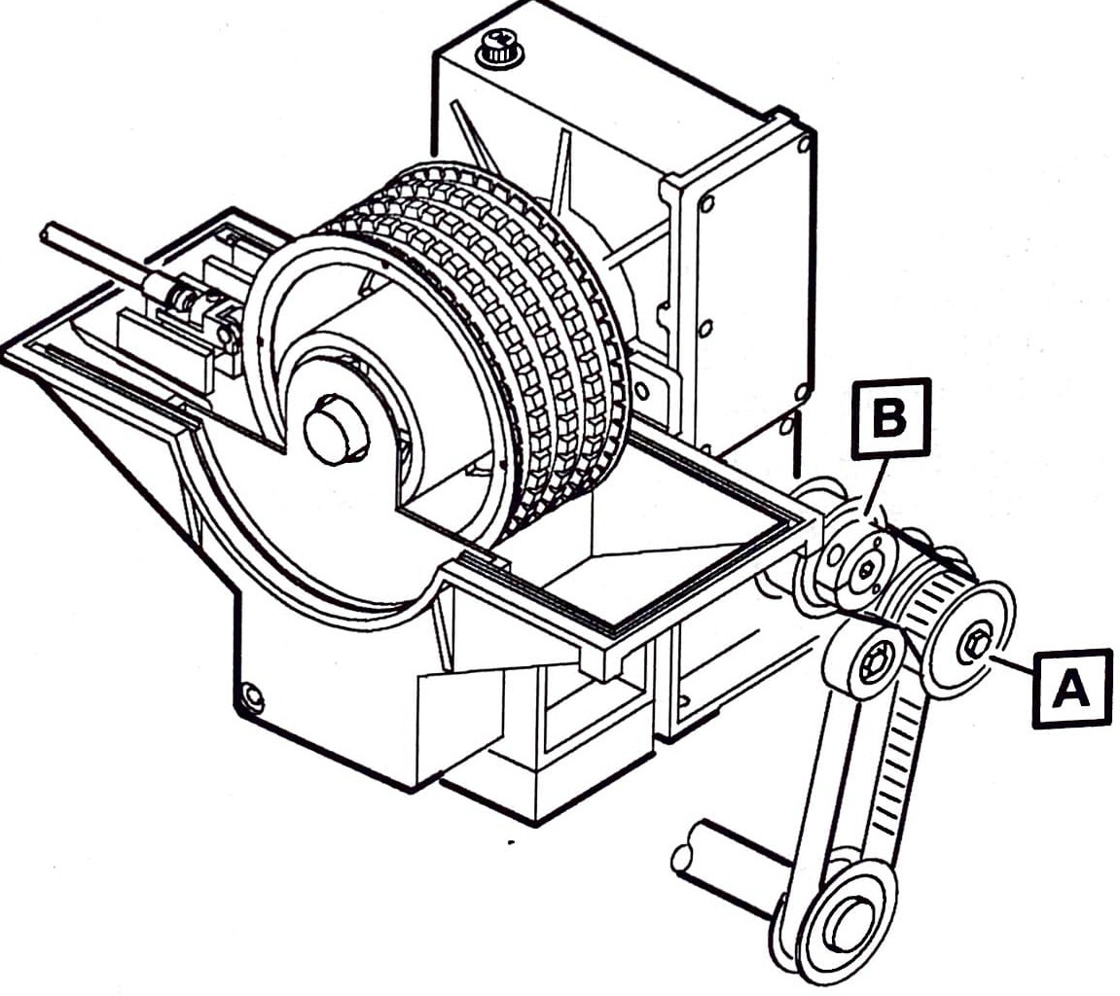

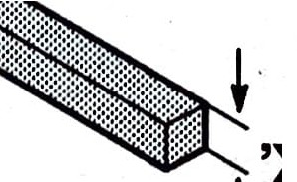
4.8 Shog setting in overlapping position

setting position -
 |  | 3 Tempi  meas. 'X' | 4 Tempi  meas. 'X'
Machine type | motion | 3 Tempi  meas. 'X' | 4 Tempi  meas. 'X'
HKS2 | 2015 | 6,5mm
HKS2-3 | 2006/2006A  2014/2014 B | 6,5mm
KS3 (P) | 2011 | 7,5mm | 32mm
KS3SP | 2011 A | 7,5 mm | 32mm
HKS3-M | 2021 | 7,5mm | 32mm
HKS3-1 | 2008 | 7,0mm | 32mm
HKS3-1 | 2020 | 6,5mm | 32.mm
HKS4/HKS5 | 2005/2007 | 7,5mm
HKS 4-1 | 2017 | 11,0 mm
HKS 4 (P) | 2019 | 7,5mm | 32mm

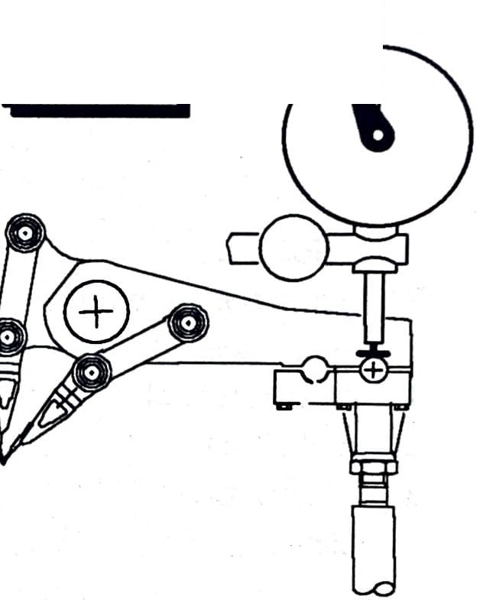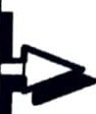machine lever:
0,01 mm falllng STOP
highesIt
p:oint

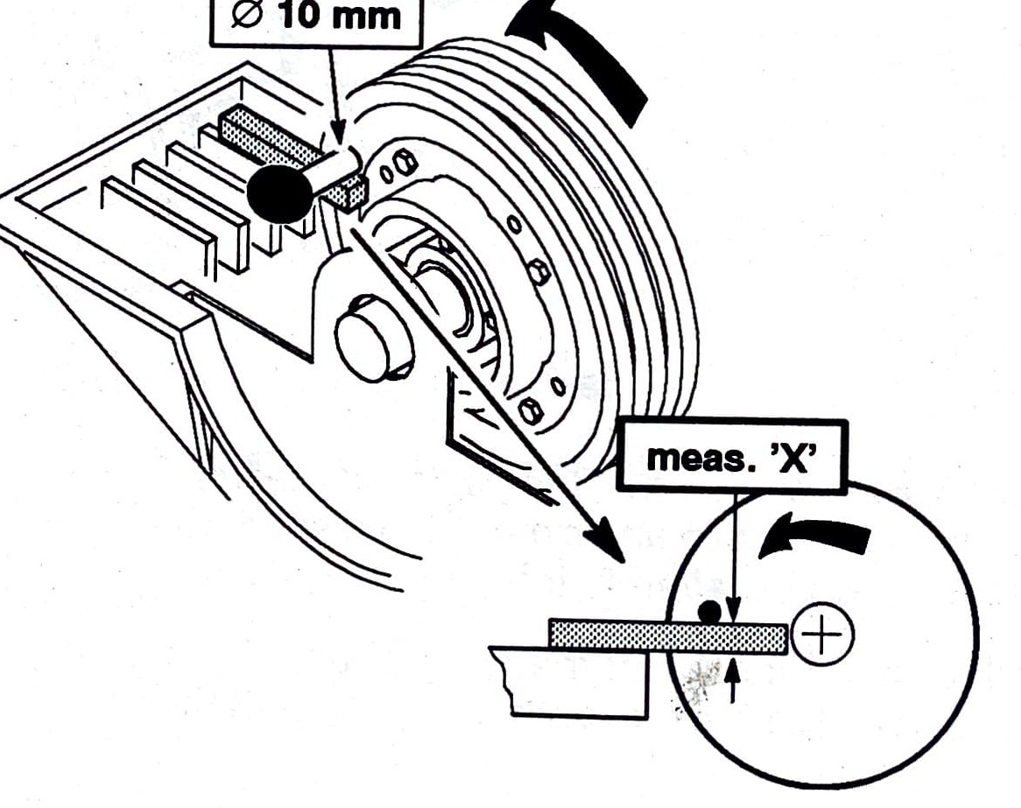
 | t 'X'
meas. .'X. ' |  | ref.J.. 10
 |  | ..
6,5mm |  | 5.32 693
7,0mm |  | 532 697
7,5mm |  | 532 698
8,3mm |  | 532 699
11,0 mm |  | 532 700
32,0 mm |  | 532 701

A:B
104:108
gg: 104
93: gg
se : 93
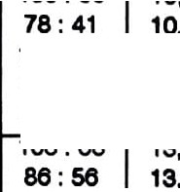
gg : 108
Machen/ atltche•
per cm per Inch
21.e12 | 55,05 | 221,5 | 8,72
21,924 | 55,e9 | 218,9 | 8,e2
22,21e | 56,43 | 21e,1 | 8,51
22,ses | 57,32 | 212,7 | 8,37
22.1e1 | 57,83 | 210,8 | 8,30
23,338 | 59,28 | 205,7 | 8,10
23,939 | eo,80 | 200,5 | 7,SQ
24,024 | e1,02 | 19Q,8 | 1,87
24,23e | e1,56 | 198,1 | 7,80

mm

p.Aack
Inch

p.Rack
Warenabzugstabelle take-up table
-------------------------------------
WECHSELRADER / change wheels:

41,56,68, 78,86,93(2x),99,104,108
-------------------------------------
Abzugswalze = 0118,6 mm
=

take-up roller

ABTRIEBSRAD
86: 104 | I  25,238 | M ,10 | 190,2 | •  7,49
56 : ea | 25,342 | M,37 | 18Q,4 | 7,46
se : 108 | 2e,208 | ee,s1 | 183,1 | 7,21
ea : se | 2e,394 | e7,04 | 181.' | 1,1e
78: 104 | I  27,82e | I  10,es | I  172,5 | t  e,79
es:93 | 28,542 | 72,50 | 1ea,2 | e,e2
78 : 108 | 28,89e | 73,40 | 1e6,1 | e,54
56: 78 | 29,oea | 73 ,83 | 165,1 | e,50
ea : 104 | 31,918 | I  81,07 | I  150,4 | I  5,92
56 : se | 32 ,050 | 81,41 | 149,8 | 5,90
es: 108 | 33,146 | 84,19 | 144,8 | 5,70
56 : 93 | 34,esa | 88,03 | 138,5 | 5,45
 | • | • |  | I
56 : 104 | 38,758 | 98,44 | 123,8 | 4,88
41 : 78 | SQ,7 03 | 100,85 | 120,9 | 4,76
56 : 108 | 40,248 | 102,23 | 119,3 | 4,70
41 : se | 43,n s | 111,19 | 109,7 | 4,32
41 : 99 | 50,392 | 128,00 | 95,3 | 3,75
41 : 104 | 52,937 | 134,46 | 90,7 | 3,57
41 : 108 | 54,973 | 139,63 | 87,3 | 3,44

'\ driven wheel
\

ANTRIEBSRAD
drive wheel
.
IGesamt-i = n1, 14: 1 I

K2-7-142-00-6
1000308553
'
Version: 1.2 fiiJi) VIE
(• :

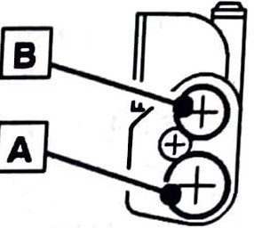He 9-7-96
A:B | Machen/ atltchn  per cm per Inch |  | mm  p.Aack | Inch  p. Rack
108 : 41 | 7,923 | 20,12 | eo5,9 | 23,85
104 : 41 | 8,227 | 20,g() | 583,4 | 22,97
99 : 41 | 8,643 | 21,95 | 555,4 | 21,se
93: 41 | 9 ,201 | 23 , 37 | 521,7 | 20,54
86 : 41 | 9,949 | 25,27 | 482,4 | 18,9Q
 | t | I | I | I
78 : 41 | 10,970 | 27,86 | 437,e | 17,23
104 : 56 | 11,237 | 28,54 | 427,1 | 1e,B2
99 : 56 | 11,805 | 29,98 | 406,e | 1e,01
93 : 56 | 12,567 | 31,92 | 382,0 | 15,04
 | I | I | t | t
86: 56 | 13,589 | 34,52 | 353,2 | 13,91
104 : ea | 13,MS | 34,ee | 351,8 | 13,85
99 : ea | 14,335 | 3e,41 | 334,9 | 13,18
78 : 56 | 14 ,983 | 38 ,oe | 320,4 | 12,e1
93 : es | t  15 ,259 | I  38 ,7e | •  314,e | I  12,38
104 : 78 | 15,e52 | 39,7e | 30e,7 | 12,07
99 : 78 | 1e,443 | 41,1e | 291,9 | 11,49
86 : es | 1e,502 | 41,91 | 290,9 | 11,45
 |  | I | I | t
es : 56 | 17,187 | 43,65 | 279,3 | 11,00
104 : se | 17 , 258 | 43,83 | 278,1 | 10,95
93 : 78 | 17 ,504 | 44 ,46 | 274 ,2 | 10 ,80
108: 93 | 17,971 | 45,es | 2e7.,1 | 10,52
 | t | t |  | I
78 : es | 18,194 | 46,21 | 2G3,8 | 10,39
104: 93 | 18,ee2 | 47,40 | 257,2 | 10,13
86 : 78  108 : gg | 18,928  19,130 | 48,08  48,59 | 253,e  250,9 | 9,98  9,88
99: 93 | t  19,eos | •  49,80 | '  244,8 | I  9,M
104 : 99 | 19,886 | 50,46 | 241,e | 9,51
108:104 | 20,097 | 51,05 | 238,8 | 9,40
93: 93 | 20,870 | 53,01 | 230,0 | 9,oe

KARLMAYER

