시뮬레이션
설정시 C: 로 되어있는지 D:로 되어있는지 확인 해야된다 프로그램 위치가
Webtexmoblie에 이미지를 가져오기 때문에 준비한다.
C:\www\webtex3d-mobile\media 가 필수 적으로 필요하다.
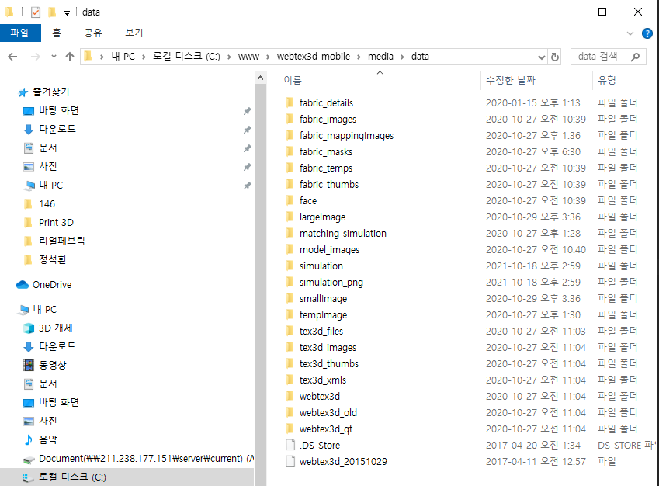

추가사항
Fabric.views.py
기존의 업로드 에서 필요한 부분 남기고 user id가 null만 아니면 등록할 수 있다.
@csrf_exempt
def createFabric_dytec(request):
valid = request.POST['Visible'].lower() == 'true' if request.POST.has_key('Visible') else False # Default = False
name = request.POST['name'] #fabric이름 가져와서
try:
category = FabricCategory.objects.get(id=33)#기본 카테고리에 저장
except ObjectDoesNotExist:
variables = {'success': False, 'reason': 'NoCategory'}
return HttpResponse(json.dumps(variables), mimetype='application/json')
real_width = 10
real_height = 10
real_size = (int(round(real_width * 59)), int(round(real_height * 59)))
user = User.objects.get(id=1)
try:
orderValue = Fabric.objects.filter(category=category).aggregate(Min('orderValue'))['orderValue__min'] - 1
except:
orderValue = 0
fabric = Fabric(name=name, valid=valid, user=user, category=category, orderValue=orderValue)
fabric.save()
IMAGE_EXTENSION = os.path.splitext(name)[-1]# path에서 확장자 분리
try:
fabricImage = request.POST['img_url']#이미지 fullpath 가져옴
res = requests.get(fabricImage)
tmp_img = Image.open(BytesIO(res.content))
# tmp_img.show()
img_format = tmp_img.format.lower()
img = tmp_img.resize(real_size, Image.ANTIALIAS)
f = StringIO()
img.save(f, img_format)
f.seek(0)
image_filename = 'data/fabric_images/' + str(fabric.id / 10000) + '/' + str(fabric.id) + IMAGE_EXTENSION
fabric.image.save(image_filename, ContentFile(f.read()))
except Exception as e:
print str(e)
try:
fabric.dpi = img.info['dpi'][0]
except KeyError:
pass
fabric.width, fabric.height = img.size
THUMBNAIL_SIZE = (115, 115)
IMAGE_TYPE = imghdr.what(fabric.image.path)
img.thumbnail(THUMBNAIL_SIZE, Image.ANTIALIAS)
temp_handle = StringIO()
img.save(temp_handle, IMAGE_TYPE)
temp_handle.seek(0)
thumb_filename = 'data/fabric_thumbs/' + str(fabric.id / 10000) + '/' + str(fabric.id) + IMAGE_EXTENSION
fabric.thumb.save(thumb_filename, ContentFile(temp_handle.read()))
variables = {'success': True, 'id': fabric.id}
return HttpResponse(json.dumps(variables), mimetype='application/json')

url.py
urlpatterns += patterns('fabric.views',
(r'^manager/fabric/category/getlist$', 'getFabricCategoryList'),
(r'^manager/fabric/category/create$', 'createFabricCategory'),
(r'^manager/fabric/category/modify$', 'modifyFabricCategory'),
(r'^manager/fabric/category/delete$', 'deleteFabricCategory'),
(r'^manager/fabric/category/switchorder$', 'switchFabricCategoryOrder'),
(r'^manager/fabric/create$', 'createFabric'),
(r'^manager/fabric/create_dytec$', 'createFabric_dytec'),
(r'^manager/fabric/create_by_product$', 'createProductFabric'),
(r'^manager/fabric/create_by_manager$', 'createManagerFabric'),
(r'^manager/fabric/copyFabrics', 'copyFabrics'),
(r'^manager/fabric/getlist$', 'getFabricList'),
(r'^manager/fabric/getlist_by_manager$', 'getFabricListManager'),
(r'^manager/fabric/getinfo$', 'getFabricInformation'),
(r'^manager/fabric/uploadtempfabric$', 'uploadTempFabricImage'),
(r'^manager/fabric/delete$', 'deleteFabric'),
(r'^manager/fabric/changeorder$', 'changeFabricOrdering'),
(r'^fabric/belonging/getlist$', 'getBelongs'),
(r'^fabric/target$', 'getTargets'),
(r'^fabric/resize$', 'fabricResize'),
(r'^fabric/upload/tempimage$', 'uploadTempImage'),
(r'^viewer/fabric/category/getlist$', 'getFabricCategoryViewer'),
(r'^fabric/isexist$', 'isExist'),
(r'^fabric/create$', 'createFabricViewer'),# 추가부분(페브릭 생성)

업로드 부분
시뮬레이션 부분의 ajax 먼저 데이터의 페브릭 이름과 path저장하여 원단을 새로 생성하는 ajax위back단에서 처리한 후 시뮬레이션 돌리는 js이다.
function upload() {
var imgsss = $('#file-image-fabric').val();
var name = $('#name').val();
$.ajax({
url: 'http://211.238.177.146:9095/manager/fabric/create',
type: 'POST',
dataType: 'json',
data: {
'name':name,
'Type':'true',
'img_url':imgsss,
},
success: function (response) {
if(response.success == true){
$.ajax({
url:'http://211.238.177.146:9095/simulation',
type:'POST',
cache:false,
data:{
'PID' : 1553,//product id�� api �� ����
'FIDS': response.id,// fabric id�� api �� ����
},
dataType:'json',
success:function (response) {
if (response.success == true){
var url = response.url;
var imgch = document.getElementById('testss');
imgch.src = "http://211.238.177.146:9095"+ url;
//$('#testss').src = "../../../www/webtex3d-mobile"+ url;
}
},
error:function () {
alert('시뮬레이션이 실패했습니다.')
}
});
}
},
error:function () {
alert('원단등록이 실패했습니다.')
}
});
}

